Write a code in Arduino IDE to interface a LDR and a LED which toggles according to (for Arduino UNO Raspberry Pi pico / Espressif Systems

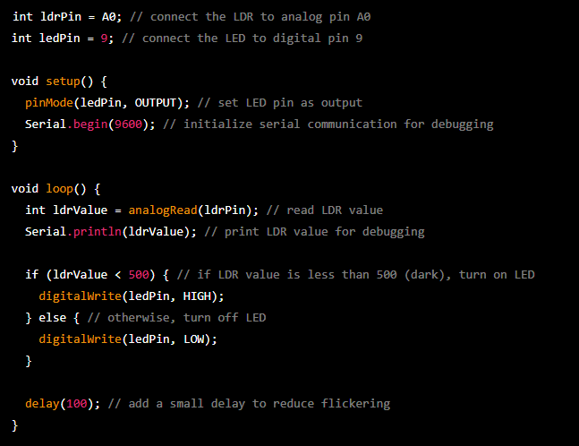

Circuit Diagram

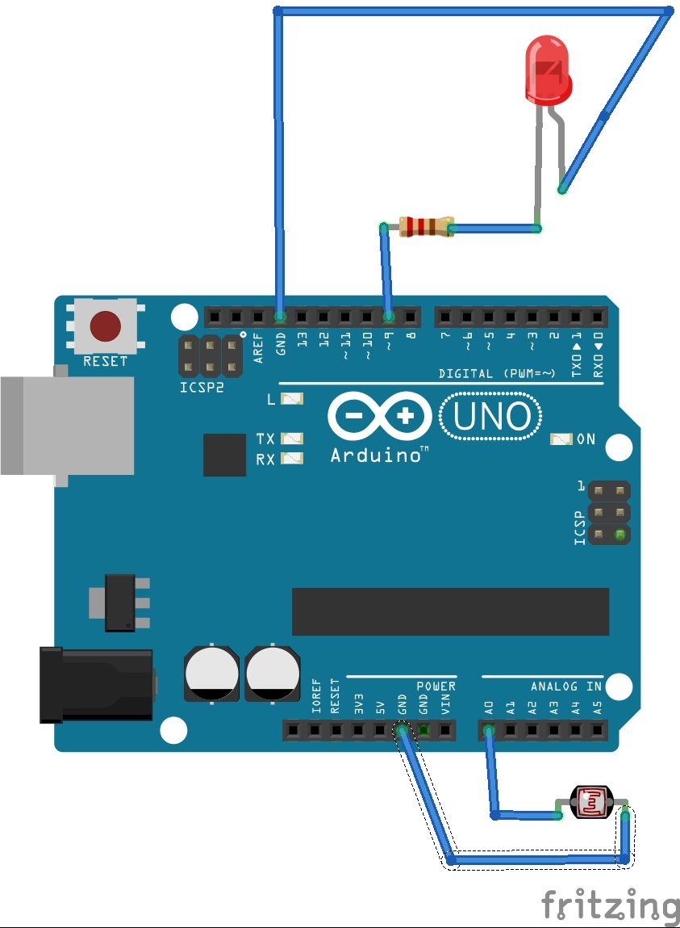

SCHEMATIC DIAGRAM

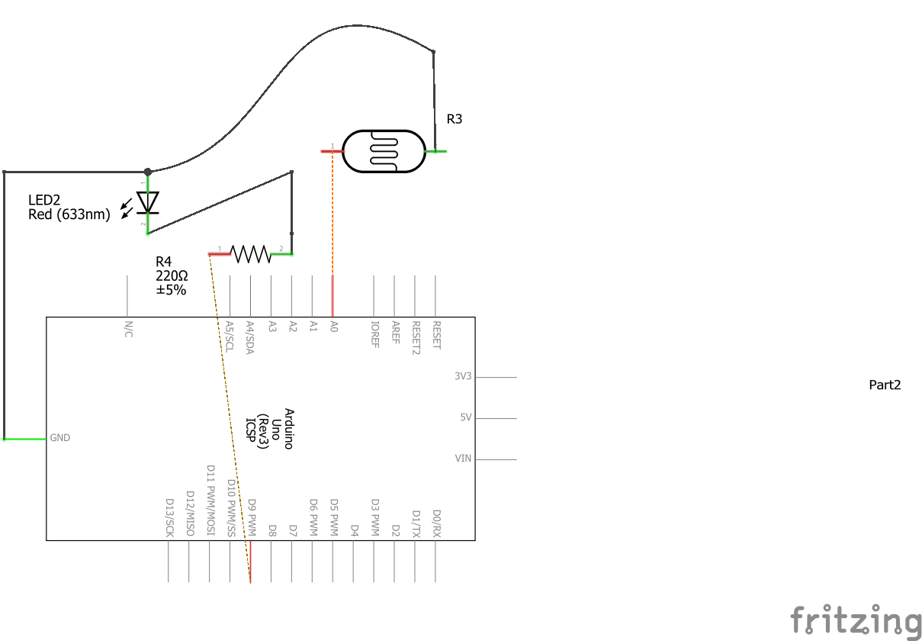

Interfacing ESP8266/12E/ESP32

or Raspberry Pi Pico with LDR and LED code in Micropython

RASPBERRY PI PICO CODE : -

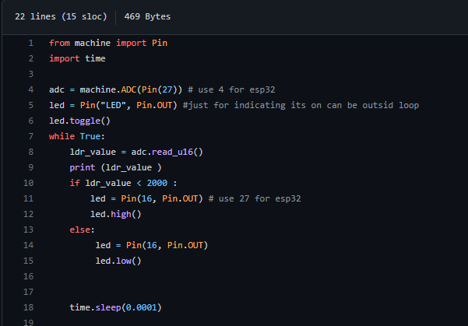

ESP32 code : -

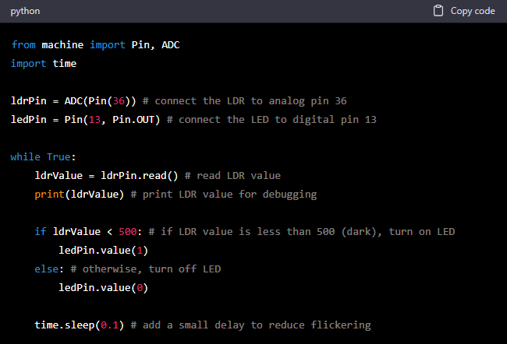

Circuit Diagram :-

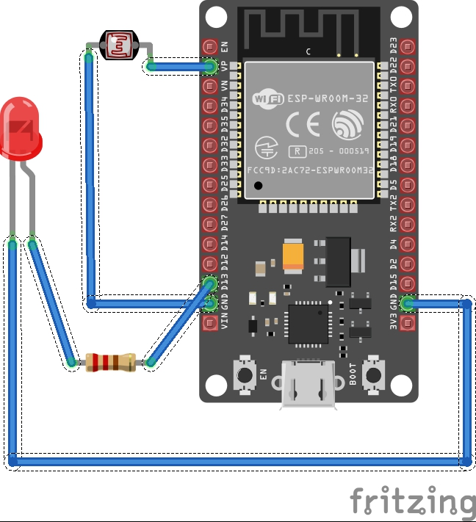

SCHEMATIC DIAGRAM

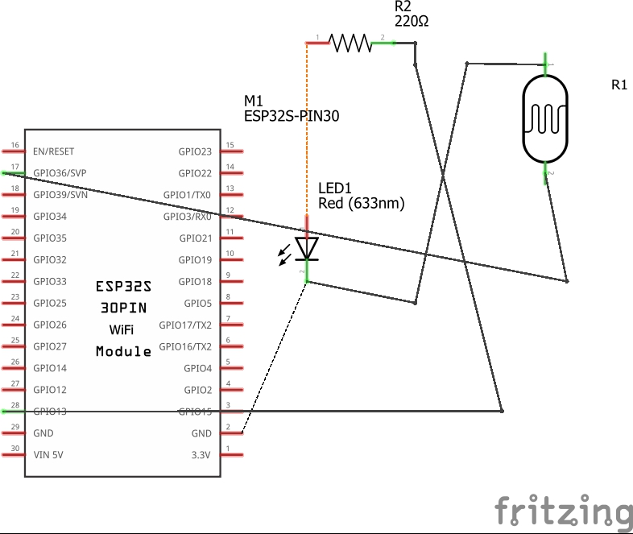

Interfacing Raspberry Pi Pico with LDR and LED code in C/C++ Pico SDK

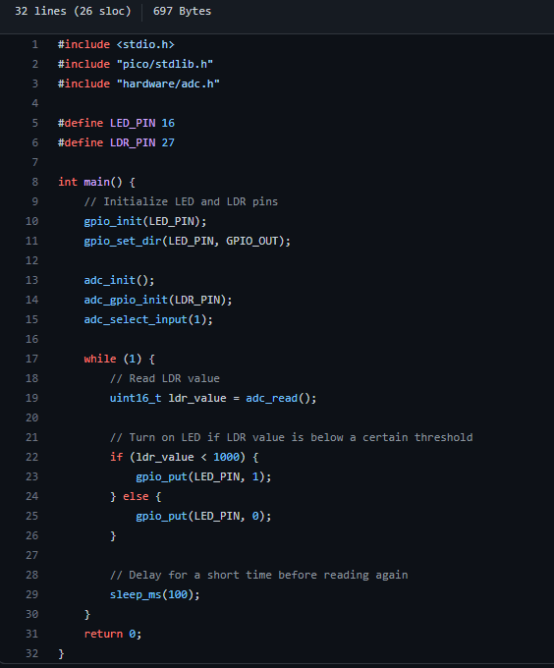

* Circuit Diagram :-

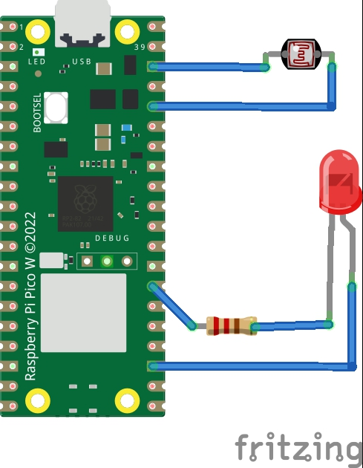

SCHEMATIC DIAGRAM

